**React**

**Introduction**

* React is a JavaScript library used for building user interfaces, especially for single-page applications(SPA).
* React is free and open-source .
* React 1st developed by Jordan Walke in 2011(facebook).
* SPA is a web application that contains a single html page that will be reloaded on the browser and update the content dynamically.
* It is component-based, meaning the UI is broken into reusable pieces called components.
* React allows efficient updates and rendering using a virtual DOM (VDOM), making it fast and scalable.

**Installation process:**

**nodejs**

Nodejs is a runtime environment which runs the js code without an outside browser.

**npm (Node Package Manager)**

* **npm** is the default package manager for Node.js. It allows developers to install, manage, and share packages (libraries or tools) required for their projects.
* You can install packages locally to your project or globally to your system.
* **npm** keeps track of your project's dependencies in a **package.json** file.

**npx (Node Package Execute)**

**npx** is a command-line tool that comes bundled with npm. It allows you to execute packages without installing them globally.

* To create React project using this command

**npx create-vite project_name**

* Run react project

**npm run dev**

**Vite**

Vite is a fast development server and built tool designed for frontend development. Vite offers a faster and more efficient development experience compared to traditional bundlers.

**How render your application in the browser**

**App.jsx** defines the main React component that serves as the entry point for your application's UI. It typically includes the structure and logic of your app.

**main.jsx/index.jsx** is responsible for initializing the React application. It imports the root component (App) and renders it into the DOM element specified in index.html.

**index.html** provides the basic HTML structure of your application. It includes a <div> with an id (commonly root) where the React application will be mounted.

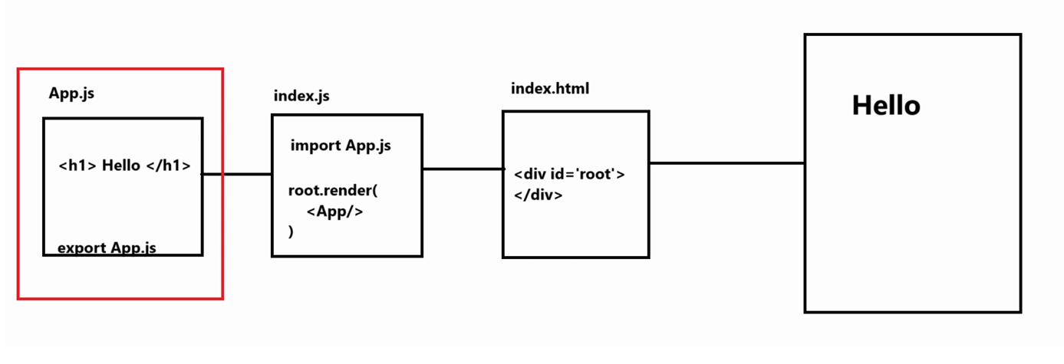

**Folder Structure:**

**node_modules:-**Contains all the dependencies that are needed for an initial working react app.

**.gitignore:-**This file specifies intentionally untracked files that Git should ignore.

**package.json:-**Project Metadata and Dependency

package.json is the configuration file for a Node.js project (including React).

**Metadata**: Information such as the project name, version, description, author, and license.

**Scripts**: Custom scripts for tasks like testing, building, or starting the application.

**Dependencies**: Lists of required packages with specified version ranges, using semantic versioning symbols like ^ (caret) and ~ (tilde).

**DevDependencies**: Packages needed only for development purposes

**package-lock.json:** Exact Dependency Versions for Consistency

● package-lock.json ensures exact versions of installed dependencies.

● It is automatically generated when running npm install.

● It prevents inconsistencies between different environments.

**README.md:-**This file can be used to define ***usage, build instructions, summary of project***, etc. It uses markdown markup language to create content.

**index.html:-**It is the template file which is served up when we run **start** **script** to launch our app. It is considered best practice not to create multiple html file in public folder instead use this file and inject react components in this file’s root div container.

**App.css:-**Contains styles of our react component([App.js](http://app.js))

**App.jsx:-**This file has very basic react component defined which can be replaced by our own root component.

**index.css:-**Contains styles for general setup of our app.

**main.jsx:-**This files renders our component.

**Features:**

**1. JSX (JavaScript Syntax Extension)**

JSX allows developers to write HTML-like syntax directly within JavaScript code. This blend simplifies the creation of React components by making the code more readable and expressive. Since browsers don't natively understand JSX, tools like Babel transpile it into standard JavaScript.

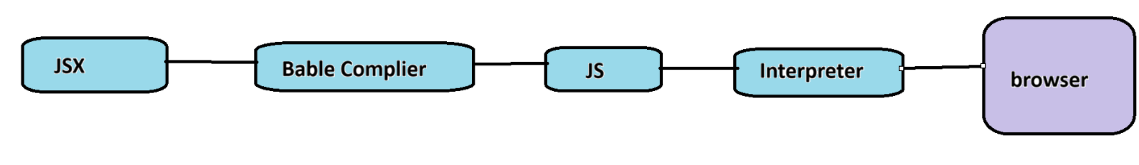Ways to write jsx:

1.div tag

2.Array

3.Fragment

4.Sugar syntax